Ejercicios de SQL

Dada la siguiente Entidad-Relación

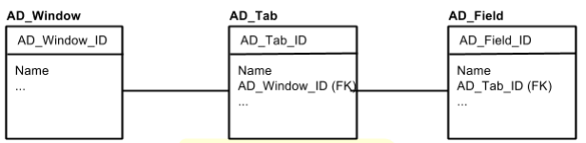

Escriba las siguientes consultas SQL:

1. Name of window with AD_Window_ID = ‘100’

**SELECT name  
FROM AD_Window  
WHERE AD_Window_ID=100**

1. Update window with AD_Window_ID = ‘100’ appending ‘--’ to the name of

window with AD_Window_ID = ‘100’

**UPDATE AD_Window  
SET Name = CONCAT(‘--’, Name)  
WHERE AD_Window_ID = 100**

1. List of all tabs in window with AD_Window_ID = ‘100’

**SELECT * FROM AD_Tab WHERE AD_Windows_ID=100**

1. List of tab name + field name of all tabs in AD_Window_ID = ‘100’ sorted by tab name and field name
2. Name and number of tabs of all windows.
3. List of all windows with its number of fields, sorting by number of fields starting by the windows with a higher number of them.
4. Windows with more than 5 tabs.

SELECT *